Lancashire Enterprise Partnership Limited

Private and Confidential: NO

Date: Tuesday, 7 September 2021

Lancashire Local Enterprise Partnership Economic Outlook Update

Report Author: Joseph Mount, Skills and Economic Intelligence Officer, Lancashire
Skills & Employment Hub, joseph.mount@lancashirelep.co.uk

Executive Summary

The report provided gives an overview of the latest data which makes up the economic outlook for Lancashire. Broadly the data we use to understand the economy in Lancashire is far from real-time, in the main, the data is annual or quarterly, though we can understand an approximation of unemployment and national economic output on a monthly basis.

- Gross Value Added (GVA) in Lancashire in 2019 increased by £907m from 2018 levels, which is a much larger year on year increase than the £289m increase from 2017 to 2018, though the 2019 figures are still provisional and will likely be revised.

- Lancashire's GVA has grown annually at a rate of 2.9% since 2015, 28th fastest of the 38 LEP areas nationally. Pendle has been the fastest growing district in Lancashire, at 5.7% annual growth since 2015, compared to a 1.53% annual contraction in Ribble Valley.

- Manufacturing now accounts for 1.6% more of Lancashire's GVA than it did in 2010, accounting for 19% of all Lancashire GVA in 2019, the equivalent of £6.6bn. Despite this, the manufacturing sector growth in Lancashire since 2015 (1.9%) has been below Lancashire's overall annual growth rate (2.9%), though the growth in Lancashire's manufacturing has been above the North West growth (1.3%).

- Administrative and Support Services, Accommodation and Food Services, and Electricity, Gas, Steam and Air Conditioning Supply have all captured a greater share of Lancashire's GVA than they had in 2010. Finance and Insurance, and Real estate have both reduced their share of Lancashire's GVA since 2010.

- The sectors which have contributed most to Lancashire's £900m+ growth since 2018, are the Health and Social Care sector, the Education Sector, and the Information and Communication Sector, with the Manufacturing sector actually shrinking by £15m between 2018 and 2019.

- The fastest growing sectors in Lancashire by GVA since 2015 are the Professional Scientific and Technical Sector (+5.1% annual growth), and the Information and Communication Sector (+5.4% annual growth), though the Information and Communication sector growth in Lancashire is 0.4% lower than the North West growth rate since 2015.

- Productivity metrics rank Lancashire in the top 3 of all LEPs nationally by growth rate, but this hasn't grown fast enough for Lancashire to catch up with other LEPs, and as a consequence Lancashire are middle of the pack in terms of productivity.

- Lancashire's job density is one of relative scarcity compared to many regional neighbours, at 0.81 jobs for every 1 working age Lancashire resident, ranking Lancashire 11th bottom in a job density league table of all LEPs, though growth would rank Lancashire in the mid-table.

- Lancashire's median gross weekly pay in 2020 was £528.10, which was the 6th lowest nationally. In the North, only North East LEP and Humber LEP had lower pay. Lancashire's pay has grown annually at 1.95% since 2015, though shrank from 2019 to 2020.

- Lancashire's claimant count rate, measuring unemployment benefit claimants, has dropped below 6% for the first time since the start of the pandemic, though still 2.3% above it's pre-pandemic level. The percentage of young people (18-24) claiming unemployment benefit is over 3% higher than it was pre-pandemic, the highest of any age group in Lancashire overall.

- Vacancies posted monthly so far this year (latest data is for June 2021), have been higher than at any point in their equivalent months in 2019 and 2020, with over 17,000 posted in June 2021 alone, higher than any individual month in the last two years.

- Over 20,000 people were "pinged" to isolate in Lancashire in July 2021 alone, putting pressure on employers that are struggling with supply chain issues and difficulties recruiting.

- As of May 2021, the economy nationally is 1.9% below it's pre-pandemic level. The recovery varies between the Service sector and the Manufacturing sector. Manufacturing output in April 2020 was 32% lower than it's 2018 levels and the service sector was 21.6% lower. In January 2021, both the manufacturing sector and the services sector were around 8% below their pre-pandemic level, and the services sector has continued to grow towards this, whereas manufacturing has wobbled slightly since.

Recommendations

- The board are asked to note the contents of the paper.

Background and Advice

The table on the following page shows a red amber green rating of various measures as outlined by the Department for Business, Energy and Industrial Strategy's LEP Economic Outlook Framework, showing reflections on the latest measures for Lancashire.
Ref | Detail | Previous Progress | Change in Measure | Current Position
1.1 | Activity that increases investment in Lancashire: Measures of grant value secured, attracting inward investment and securing financial investment including leveraging private and public funding | Good | +13.5% YoY, 17th fastest growth nationally for HEI grants.  10% increase in UKRI and Innovate UK Grants  Inward Investment Successes -4 projects; + 3577 jobs; value +£1.46bn | £50.7m 2018/19, Ranked 20th nationally for HEI grants.  Ranked 26th nationally for UKRI and Innovate UK Grants (295 active)  18 projects 2020/21; jobs created; value £3.8bn
1.2 | Activity that increases the Value of Lancashire's Economy: Annual measures of GVA and GVA per hour / per worker | Increasing and gap narrowing. | Productivity 2nd and 3rd fastest growing nationally (per hour and per job)  Overall GVA growth 2.9% annually (last 5 years), 28th fastest growing. | Ranked 20th and 22nd for Productivity Per Hour (£31.32) and Per Filled Job (£49,717) respectively. Improved 10 places in ranking for both measures since 2010.  Ranked 17th for overall GVA (£34.4bn). Improved 1 place in ranking since 2010.
1.3 | Activity that increases the number of businesses, jobs and people in employment: Measures of the number of business (count); job numbers / density; and employment rate | Count and density increasing | 1.33% average annual growth rate in business count. 28th fastest growing.  2.4% increase in employment rate, 10th fastest growing.  Job density increased by 0.03 since 2015, 20th fastest growing. | 14th highest business count (52,000), reduced 1 place in the ranking since 2010.  28th highest employment rate (75%).  27th ranked for Job Density (0.81)
1.4 | Activity that increases the strength of the workforce including by attracting and retaining talent and increasing skills and apprenticeships aligned to business need: Measures of growth in working age population; increasing numbers of NVQ4, HE Qualifiers, Leavers working Locally, Apprenticeships, employment levels in science and technology, and tackling hard to fill vacancies / skills shortages | % over 64 increasing greater rate than UK; HE qualifiers down; NVQ4 gap improving | -2.41% annual contraction over the last 5 years in HE qualifiers, ranked 34th nationally.  +5.8% growth in % qualified to NVQ4+ since 2015, ranked 16th for growth.  -0.5% contraction in % with a trade apprenticeship, rank improved from 15th to 10th nationally.  7% annual growth rate in the number of people working in STEM in Lancashire, 2.8% above national average. | Ranked 14th nationally for HE qualifiers (17,000).  Ranked 31st nationally for % qualified to NVQ4+ (36.4%).  Ranked 10th for % with a Trade Apprenticeship (3.7%). Improved 5 places in ranking since 2015.  Ranked 26th nationally for % working in STEM (7.2%, 50,000 people).  Ranked 6th bottom for percentage of vacancies which are hard to fill (46%, 8500+ vacancies) and ranked bottom for percentage of vacancies that are hard to fill due to skills shortages (36%).
1,5 | Activity that improves and strengthens business performance: Measures of business start ups reaching milestones (£1m/£3m) and 3yr survival rate; increasing high growth, R&D firms and product innovators | start up performance and survival, high growth, R&D, innovators increasing | - | Ranked 6th nationally for percentage of start-ups reaching £1m turnover within 3 years (2.1%).  Ranked 30th nationally for percentage of scaleups reaching £3m turnover within 3 years of reaching £1m turnover (6.5%).  Ranked 19th nationally for high growth firms (20% annual average employment growth for businesses with 10+ employees), 5.9% of firms in Lancashire.
1.6 | Activity that supports and engages business in improving prosperity, the environment and quality of life: Overarching measures of prosperity, environment and quality of life (to which the LEP has a role to play alongside other Lancashire partners and stakeholders) including gross disposable income and earnings, reducing carbon and CO2 emissions and life satisfaction score | GDI falling and gap widening; CO2 emissions improving but gap widening; LSS | Gross weekly pay grown at 1.95% annually since 2015, below national rate of 2.01%, ranked 17th nationally by growth in median gross weekly pay. Pay reduced from 2019-2020.  Life satisfaction score since 2015 has increased by 0.03 (out of 10.0) in Lancashire County, reduced by 0.11 in Blackpool, and increased by 0.18 in Blackburn with Darwen, compared to no change in the UK. | Ranked 32nd nationally by median gross weekly pay (£528.10).  Life satisfaction score isn't aggregated by LEP area, but for the constituent areas of the Lancashire LEP, the County area and Blackburn with Darwen both have a Life satisfaction score above the UK rate, Blackpool's is 7.55 compared a national average of 7.66.

1.0 Introduction

1.1 Lancashire GVA has grown slowly, but ranks in the top 20 of all LEPs nationally, whereas Lancashire's productivity per hour worked and per filled job has grown fast. These productivity metrics rank Lancashire in the top 3 of all LEPs nationally by growth, but this hasn't grown fast enough for Lancashire to catch up with other LEPs, and as a consequence Lancashire are middle of the pack in terms of productivity measured as total GVA. Lancashire's job density is one of relative scarcity compared to many regional neighbours, ranking Lancashire 11th bottom in a job density league table of all LEPs, though growth in job density would rank Lancashire in the middle quartile nationally. Lancashire's pay ranks poorly, with Lancashire in the bottom quartile of all LEPs nationally for Median Gross Weekly Pay, growing more slowly in Lancashire than nationally.

1.2 Gross Value Added GVA

1.2.1 The latest provisional figure released for GVA in Lancashire for 2019 is £34.393bn which constitutes a nominal increase of GVA from 2018 to 2019's provisional estimate of £907m, compared to the 2017 to 2018 increase of £289m. All GVA figures quoted are pre-pandemic, and are published with a lag, it may be 2023 before we have a view on Lancashire's GVA from 2021.

1.2.2 As it stands, Lancashire's annual growth rate of GVA in current prices is 2.91% since 2015, this ranks Lancashire 28th of all LEPs in England by growth over this period, though Lancashire does rank 16th nationally in terms of the size of GVA (an improvement of 1 place since 2010), and is the 2nd largest in the North West (after Manchester). Compared to Lancashire's trend of growth since 2015, the growth in 2019 from 2018 levels has been below the 2.91% trend, at 2.7%.

1.2.3 Different districts within the Lancashire LEP area have had different successes in growth in GVA, with Pendle leading the way in terms of an annual growth rate since 2015 of 5.7%, followed by Blackpool with 5.3%. Ribble Valley is the only district with a negative growth rate of (-1.53%) since 2015, representing a £22m contraction in GVA since 2015.

1.2.4 Clearly geographic specialisms in sectors have a role to play in determining the relative health of a local economy, and so it's interesting to understand which sectors are becoming increasingly more dominant in Lancashire by their share of GVA, and to understand how this might influence what appears to be local performance.

1.2.5
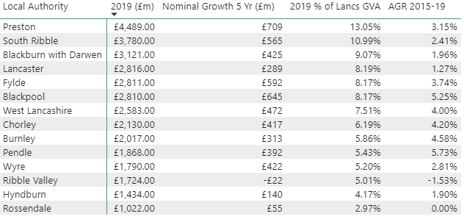
Figure 1: Lancashire LEP District/Unitary Authorities, GVA. Source: ONS Data from Lancashire Skills and Employment Hub Evidence Base

1.2.6

Figure 2: Lancashire Gross Value Added by Broad Industry Sector. Source: ONS Regional Productivity, 2021.
1.2.7 Manufacturing has captured a further 1.6% of Lancashire's GVA compared to 2010, now accounting for 19% of Lancashire's 2019 GVA, the equivalent of £6.6bn in annual output. Lancashire's manufacturing output as a proportion of it's overall output is 19%, for context 15% of output in the North West comes from Manufacturing and 10% of output in the United Kingdom. Lancashire accounts for 24% of all manufacturing output in the North West.

1.2.8 Other sectors which have increased their share of Lancashire's GVA in 2019 relative to their 2010 share include the Administrative and Support Services Sector, which now accounts for 0.9% more of Lancashire's GVA than it did in 2010. Accommodation and Food Services sector has also grown it's share by 0.4% over the same time period as well as Electricity, Gas, Steam and Air Conditioning Supply.

1.2.9 Sectors which have experienced a drop in their percentage of Lancashire GVA in 2019 relative to 2010 include the Financial and Insurance Activities Sector, which has fallen by 1.4%, Real Estate which has fallen by 1.05%, and Public Administration and Defence, which has fallen by 0.9%. Lancashire's Human Health and Social Work Sector and Professional, Scientific and Technical Activities sectors have also both fallen by 0.3% since 2010.

1.2.10 In terms of sectors which contribute most to Lancashire's GVA, the Manufacturing sector (as aforementioned) contributes 19%, Wholesale and Retail Trade 14% (equivalent of £4.8bn), Real Estate 12% (£3.9bn), Human Health and Social Work 10%(£3.4bn), and Construction with 7% (£2.3bn).

1.2.11 Despite the Manufacturing sector increasing its "market share" of Lancashire's GVA since 2010, its growth rate since 2015 has been below Lancashire's overall trend growth rate (of 2.9%), with annual growth over the same period at 1.9%. Despite being below Lancashire's overall trend growth, growth in the Manufacturing sector in Lancashire has outstripped North West growth in the Manufacturing sector, which has grown annually at 1.3% since 2015. In some areas of Lancashire, the manufacturing sector has actually seen a negative growth rate since 2015, with Preston (-1.5%), Ribble Valley (-2.2%) and South Ribble (-1.9%) all reporting negative annual growth in this sector since 2015. Those three areas have positive annual growth rates if you look from 2010 onwards, so it would suggest the growth in the last 4 years wasn't as strong as the 4 years preceding them. It is interesting to note that these 3 areas account for 26.3% of Lancashire's manufacturing GVA.

1.2.12 At the same time as understanding post 2015 growth trends by sectors, it's also important to take into account the previous year's performance. Lancashire's GVA growth between 2018 and 2019 is provisionally over £900m, which is far higher than previous years, the sectors which have contributed most to this are the Human Health and Social Work Activities sector (+£153m), Education (+£142m), Information and Communication (+£106m). It is interesting to note that despite being Lancashire's highest value sector, the Manufacturing sector (along with Finance and Insurance, and the Arts) actually shrank between 2018 and 2019 by £15m, a -0.2% growth.

1.2.13 Positives to note are the GVA growth in Lancashire's Professional Scientific and Technical sector (5.1% annually since 2015), and Information and Communication sector (5.4% annually since 2015, though 0.4% below North West growth over the same period). It's important to remember these figures are pre-pandemic, and we have only anecdotal information on the present health of sectors, such as a drop in demand in the civil aviation market.

1.3 Productivity: GVA Per Hour Worked and GVA Per Filled Job

1.3.1 Despite a mixed picture in growth of GVA for Lancashire since 2015, the productivity measures which underpin this have been extremely encouraging. We can see GVA Per Hour worked and GVA Per Filled Job growing at over 3.3% annually since 2015, the second and third fastest growing of all LEPs nationally.

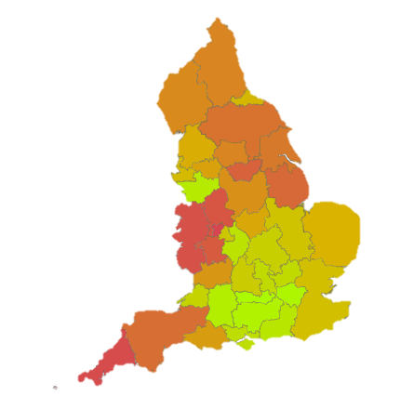
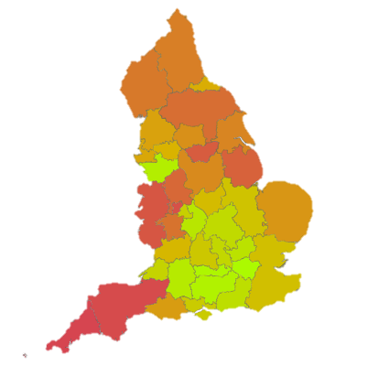
1.3.2
Figure 3: GVA Per Hour Worked (Left) and GVA Per Filled Job (Right). 2018 Rank (Green = More Productive, Red = Less Productive). Source: ONS, 2020

1.3.3 When measuring GVA Per Hour Worked in Lancashire, for which 2018 is the most recent data, Lancashire rank 20th nationally, with £31.32 of GVA created on average by each Lancashire worker every hour, this is a considerable improvement from the 2010 position, when Lancashire ranked 29th. Lancashire is ranked the 3rd highest in the North West, after Cheshire and Warrington (5th nationally) and Liverpool City Region (17th nationally), and just ahead of Manchester (22nd nationally).

Over the 3 years of data we hold since 2015, Lancashire's productivity by Per Hour Worked has grown annually by 3.32%, which is the third highest annual growth rate of all LEP areas nationally.

1.3.4 Lancashire's GVA Per Filled Job stands at £49,717 as of 2018, which is the 22nd highest nationally, and 4th highest regionally. Cheshire and Warrington produce over £10,000 of output more per filled job, Liverpool produce £200 more per filled job, and Manchester £500 more per filled job). Lancashire's position nationally has improved by 10 places since 2010, and since 2015 Lancashire has grown this measure annually by 3.37%. Lancashire's 3.37% annual growth in GVA Per Filled Job since 2015 ranks it the second fastest growing nationally.

1.4 Jobs Density

1.4.1 Job density figures can reveal insight into Lancashire's economy. Jobs density is defined as the number of jobs in a geographic location (in this case, Lancashire) as a proportion of the resident working age population in the same geographic location (again, in this case, Lancashire). A jobs density figure of 1.0 would indicate that there is a job in the area for every working aged resident, but it is worth bearing in mind that the Great Britain (GB) average is 0.87 and the North West average is 0.86. The GB rate provides a basis for comparison by which we can infer whether Lancashire has disproportionately fewer jobs locally than would be expected of the average LEP area.

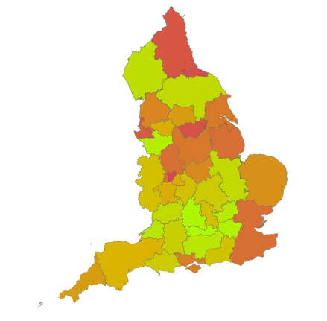
1.4.2

Figure 4: 2019 Job Density by LEP Area, 2019 Rank (Green = Dense with Jobs, Red = Less Dense with Jobs). Source: NOMIS, 2021

1.4.3 2019 Jobs Density (latest data) for Lancashire is 0.81, 0.5 below the North West and 0.6 below the GB average. Lancashire's job density is the 27th highest nationally and has improved since 2015 by 0.03 (from 0.78 to 0.81). Despite the improvement, Lancashire's job density has improved by less than the average improvement nationally (0.05), and consequently, Lancashire ranks 20th nationally for improvement in this metric, and 4th regionally, having a higher jobs density than only Liverpool City Region in the North West.

1.4.4 This would imply there are relatively fewer opportunities in the labour market to spread between the working age population that what would be typically expected nationally.

1.4.5 The location of major employment sites that attract commuters from outside of the area can be a major influence on this, and consequently there is considerable variation across the districts in Lancashire in the job density metric.

1.4.6 By way of example, Preston, Fylde and Ribble Valley all have job density figures approaching or above 1.0, as a consequence of large individual employment sites. Some examples include the presence of BAE at Samlesbury (Ribble Valley, this goes some way to explaining Ribble Valley's 0.98 jobs density in 2019), BAE's, Springfield Fuel's and Fox's Biscuits presence in Fylde (which go some way to explaining Fylde's 1.03 job density), and all of the associated employers in Preston (1.1 job density).

1.5 Wages/Pay

1.5.1 Lancashire's median gross weekly pay in 2020 was £528.10, which was the 6th lowest nationally, though we have grown accustomed to higher rates of pay being concentrated in the South and particularly the South East and London, possibly as a consequence of the cost of living.

1.5.2
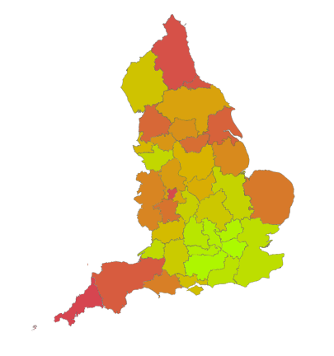

Figure 5: Median Gross Weekly Pay by LEP, 2020 (Green = Higher Pay, Red = Lower Pay). Source: NOMIS, 2021

1.5.3 In addition to Lancashire having the 6th lowest median gross weekly pay, it is also the lowest in the North West, which has been the case for the majority of the period since 2014, with the exception of the deviation in 2017 where it was joint lowest in the North West with Manchester at £517.50 weekly). In the North, only North East LEP and Humber LEP had a lower median gross weekly pay.

1.5.4 Lancashire worker's pay has averaged positive growth annually since 2015 at a rate of 1.95%, and compared to inflation (as measured by the consumer price index, and relative to 2015, i.e 2015 = 100), the average annual growth in pay would've been below Inflation in 2017 (2.7%) and 2018 (2.5%), and slightly above in 2019 (1.8%).

1.5.5 Lancashire's growth rate of 1.95% in this measure is the 17th highest of all LEP areas nationally, though below the GB rate of 2.01% growth and worker's did experience a reduction in median gross weekly wages from 2019 to 2020, which in the North West happened in only Cheshire and Warrington and Lancashire.

1.6 Employment and Unemployment

1.6.1 As of 2020, the official employment rate in Lancashire was 75.4% (this rate is for the 12 months in the 2020 calendar year), and is the 28th highest nationally. This rate has gone up 2.4% since 2015, and represents the 10th largest increase nationally, which is positive, though the rate remains below the overall UK rate of 75.4%, but above the North West rate of 74.2%. Of the 75% employed in Lancashire, 9.8% of them are believed to be self-employed (the equivalent of 98,500). Whilst the Employment rate is a useful measure, as is the unemployment rate, the nature of it being aggregated annually means in some scenarios we can get more insight on unemployment (official rate 3.4%, lower than the regional and national rate), by looking at Universal Credit Claimants (Claimant Count).

1.6.2 Looking at the Claimant Count allows us to get a monthly, local, approximation of those claiming unemployment support by age and gender. In Lancashire, the percentage of working age residents claiming universal credit was 3.7% pre-pandemic (March 2020), which was in-line with the North West rate, and 0.6% above the GB rate. Following the pandemic, joblessness increased substantially and as such, we saw a claimant count rate as high as 7.0% in May 2020, with the number of claimants almost doubling to 63,500. The percentage of people claiming universal credit has reduced as business conditions begin to return to normal, with the rate in Lancashire now (as of June 2021 data released in July 2021) down to 5.9%, the first time it has been below 6% since the start of the pandemic. Lancashire's 5.9% is 0.3 basis points below the North West rate, and 0.3 basis points above the GB rate.

1.6.3 In general, rate differs depending on the age of the worker, and pre-pandemic there were existing differentials, such that the rate for those aged 18-24 in Lancashire was 1.2% above the average for the general population, those aged 25-49 claimed at a rate 0.5% higher than the general population, and those aged 50+ claimed at a rate of 1% below the general population rate.

1.6.4 This has been exacerbated considerably by COVID19, and in May 2020, the rate for young people was 2.7% above the average rate, and for those aged 25-49 the rate was 1% above the average rate, those aged 50+ claimed at a rate 2% below the average rate.

1.6.5 Thus younger workers have been affected more severely than older, though clearly the wider rate has increased considerably over this time. As of June 2021, 8.1% of young people were claiming universal credit because of unemployment (3.2% higher than pre-pandemic), 6.8% for those 25-49 (2.6% higher than pre-pandemic), and 4.3% for those aged 50+ (1.5% higher than pre-pandemic).

1.6.6 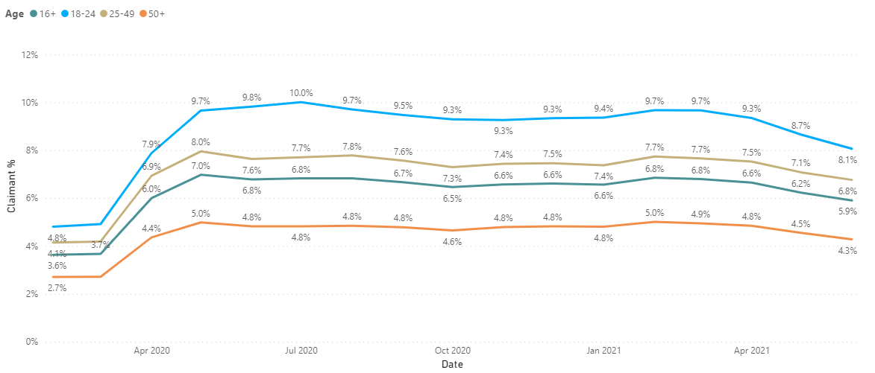
Figure 6: Claimant Count (%) in Lancashire Jan2020 to Jun2021, by age. 16+ is all ages and overall average. Source: NOMIS, 2021

1.7 Vacancies and Opportunities

1.7.1 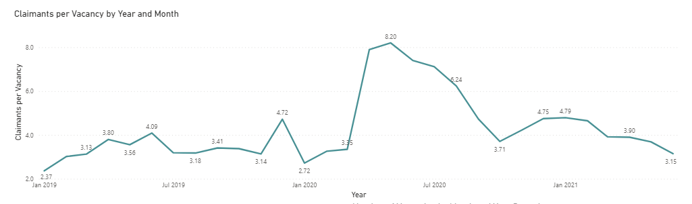
Figure 7: Claimants Per Vacancy, Number of Universal Credit Claimants for every vacancy posted monthly in Lancashire. Source: Lancashire Enterprise Partnership Analysis of Burning Glass Vacancy Data and ONS Claimant Data, 2021.

1.7.2 Using online vacancy posting data from Burning Glass, we're able to gauge a relative measure of opportunity for Lancashire workers who might be searching for work. The data reveals vacancy postings online at record levels, and some insight into which sectors and occupations businesses are recruiting for. Vacancies posted monthly so far this year (latest data is for June 2021), have been higher than at any point in their equivalent months in 2019 and 2020, with over 17,000 posted in June 2021 alone, higher than any individual month in the last two years. Despite high vacancies posted, at points in the pandemic there were over 8.2 claimants to universal credit "competing" for every 1 vacancy posted in that month, compared to a pre-pandemic range of between 2.37 and 3.35 claimants per vacancy. The number of claimants per vacancy metric is now beginning to fall, and as of most recent data sits at 3.15 claimants for every vacancy posted in June 2021, the lowest since January 2020, and bettered only by January, February and November in 2019. Despite opportunities appearing to be abundant, businesses such as those in the hospitality sector are still reporting difficulties in filling these vacancies.

1.8 Business Threats from COVID19 NHS Track and Trace Self-Isolation

1.8.1 Nationally there has been lots of coverage of employers suffering from staff needing to self-isolate, the so-called "Pingdemic", with news reports of over 600,000 workers nationally self-isolating at points in July 2021. Such data pertaining to local authority contact tracing alerts has been released by the NHS. For Lancashire, we can get a novel experimental view on the number of individuals identified as contacts of someone who has tested positive for COVID19 and may need to self-isolate as a result, meaning they're unable to attend work, which causes difficulties for business. This data has been released from October 2020 to the present day, and the most recent week's data suggests that over 10,000 individuals in Lancashire were notified of a close contact by the NHS COVID19 app in the week ending 14th July 2021, the highest of any week in the pandemic thus far, with almost 20,000 asked to self-isolate by this point in July, which compares to 28,304 notifications throughout the entirety of the second quarter of 2021 calendar year.

1.8.2
Figure 8: Number of Contact Tracing Alerts from NHS COVID-19 App in Lancashire, weekly. Source: NHS App Statistics
1.8.3 This adds to pressure already being felt by businesses in sectors where they're struggling to recruit staff, such as the hospitality sector, the added complexity of the existing base of staff having to self-isolate at some point has a significant impact.

1.9 The National Picture

1.9.1
Figure 9: UK Gross Domestic Product, Month on Month Percentage Growth, Seasonally Adjusted. Source: ONS, 2021
1.9.2 The national picture is unchanged from the data published in the LEPs annual report, with the most recent quarter (2021 Q1) of Gross Domestic Product ~1.6% below the previous quarter's GDP. That being said, the ONS do now produce a monthly estimate of GDP, showing percentage change in output from the previous month. Since February, the economy has seen consecutive months of growth, to varying extents, with growth beginning to tail off since March (where output was 2.4% above February output), with May data being the latest view, a 0.8% growth in GDP from April.

1.9.3

Figure 10: UK Monthly GDP Index (2018=100), Overall GDP, Service Sector output, Manufacturing Sector Output. Source: ONS, 2021
1.9.4 Despite improved growth in the national economy, as of May this year, the economy still stands 1.9% smaller than it's 2018 levels, the closest the UK economy has been to parity with 2018 since the start of the pandemic. The recover varies depending on the sector, and when grouping into Service sector and Manufacturing sectors, the results differ considerably. Manufacturing output in April 2020 was 32% lower than it's 2018 levels, much lower than the service sector (which fell 21.6% from it's 2018 levels). The gap between Manufacturing and Services (relative to their respective 2018 levels) did narrow and indeed achieved effective parity in January when both Manufacturing and Service sector output was around 8% below it's 2018 levels, since March however, Service sector output has continued to grow closer to it's 2018 level, whereas Manufacturing has remained static, and actually fallen by 0.1 basis point between March and May.

1.9.5 The Office for Budget Responsibility's (OBR) has developed various scenarios on the National Recovery. Pre-pandemic, their March 2020 forecast showed an expectation that the UK economy as measured by real GDP would be around 8% bigger in the first quarter of 2025 than it was in the final quarter of 2019. As the impact of the pandemic emerged, these scenarios were revised in November of 2020, with a central scenario showing the UK economy only 4.5% larger than its pre-pandemic level, with variation around that point. It's therefore expected that the economy will feel the effects of scarring from the impact of the pandemic for some time. Lancashire's challenge is to minimise that scarring by enhancing productivity and a return to growth in the region quickly. The challenges faced will vary somewhat across Lancashire's districts as a consequence of their differing structural compositions, employment and business specialisms.

1.9.6
Figure 11:OBR Real GDP Central Forecast and Scenarios. Source: OBR Economic and Fiscal Outlook - March 2021

Summary

Lancashire is showing signs of recovery, through continuous steady drops in the
number of individuals claiming unemployment support, and through a reduction in
the number of individuals furloughed. The years before the pandemic show some
signs of optimism in terms of growth in productivity, but the general size of
Lancashire's economy is more slowly growing and varies across sectors.

List of Background Papers

Paper | Date | Contact/Tel
N/A

Reason for inclusion in Part II, if appropriate

N/A

